Volunteer Newsletter
Spring 2022

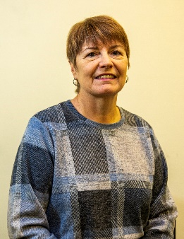
Contents
Introduction
- Volunteers’ get-together 2022
- Volunteer tech team
- Volunteer zoom meeting
- Gardening volunteers
- Spotlight on volunteers
- Share why you volunteer

Hi everyone

I hope you have had a good start to the year. We have been very pleased to welcome several new volunteers to Sight Concern Worcestershire as there are still lots of referrals coming in for support. If you, or anyone you know, could offer some time as a befriender (from just a couple of hours a fortnight), please contact me. I am always happy to talk through what is involved with no commitment necessary.

As always, thank you for you all that you do – it is hugely appreciated by our clients, our trustees, and the staff team.
Jackie Murrall - Volunteer Coordinator

1. Volunteers’ Get-together 2022
We were delighted to be joined by around 40 volunteers at our recent meeting at Bennetts Willow Barn in Worcester. We enjoyed catching up with everyone over cakes (kindly donated by Waitrose) before hearing from Aj, our Technology Coordinator, about how technology can support people with a visual impairment.
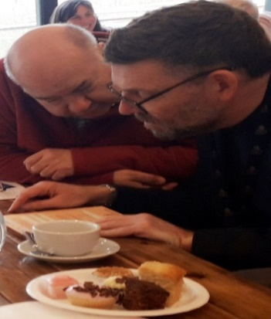
One volunteer commented on how interesting it was to hear about Aj’s personal experience of using braille in the education system, as well as technology available as standard on many smart phones, tablets, and laptops.

If you know or support a client who would like to know more about what is available, please give Aj a call on 01905 723245 or email: a.ahmed@sightconcern.co.uk

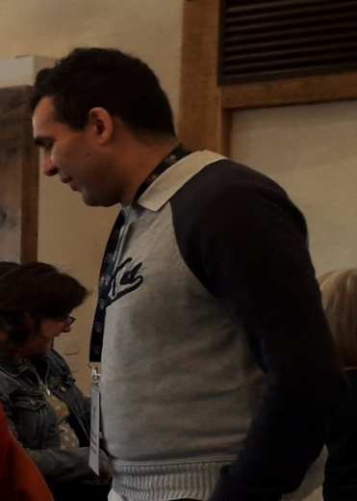
2. Volunteer Tech Team - Coming Soon!
Some of you will have met Aj, our Technology Coordinator, at our recent volunteer meeting. We would now like to develop a volunteer tech team to offer short=term follow up support to our clients to get to grips with new technology. We are looking for people who are: -

- Enthusiastic about gadgets and technology
- Competent using smart phones and tablets
- Confident downloading and using apps
- Familiar with using smart speakers such as echo devices
- Comfortable using windows on a computer.

Volunteers need to be patient, keen to help others and comfortable visiting a client at home to offer the support needed.

Aj will train each volunteer about the accessibility options on these devices so no prior knowledge of accessibility is required. If you know someone, who could support our clients with visual impairment to use technology, please ask them to contact Jackie on 07570 323913 email: j.murrall@sightconcern.co.uk for further info. Aj would also be happy to have an informal chat about the role with them.

3. Volunteer Zoom meeting
Our next Zoom volunteer support meeting will take place on Wednesday 11th May at 11 am. It is an opportunity to meet some of our newer volunteers and catch up with those who have been involved with us for a while.

Please let Jackie know if you would like to join us and she will send the joining instructions out nearer the time – you can also dial in by phone if you are not able to join by video.

4. Gardening Volunteers Wanted
Do you enjoy gardening but maybe don’t have access to your own garden? The garden at our Bradbury Centre in Worcester needs a spring tidy up and we would be grateful if there is anyone who can help, especially now that the weather is getting better. If you are interested, please call Jo on 01905 723 245 or email info@sightconcern.co.uk

5. Spotlight on Volunteers
Two of our longstanding volunteers have kept up the spirits of our Bromsgrove support group members since the first lockdown in March 2020.

Enid Bishop, who has volunteered for Sight Concern for the past 9 years, and Jess Greenhough, who has volunteered with us for 29 years, were both regular helpers at the Bromsgrove group. When the group had to close, they both stayed in contact with all the members, calling them regularly to make sure they were okay.

When restrictions lifted Enid, rallied everyone together for a monthly gathering in Wetherspoons’ garden, later moving indoors when the weather got colder. At a time when everyone was really struggling with the tedium and monotony that had become part of daily life this support network was a massive boost to everyone’s mental health. Here is what some of our regulars have said: -

“They have been quite brilliant, always wanting to help and keeping us happy. We would have been quite lost without them.” Pat Adams

Kath Solly, whom Enid met several times at the bus stop to help her cross a busy road said: “Both Enid and Jess have done remarkably well keeping us all together, they have both been golden.”

Nalda Taylor, who hadn’t been out of the house for months was really grateful for all the calls and encouragement and, after a long time recovering from a fall, ventured out again and joined her friends.

“They have been brilliant, keeping in touch with us all, it was always nice to hear a friendly voice.” Hazel Guest

From all of us at Sight Concern Worcestershire, a big thank you to Enid and Jess for keeping everyone going. We couldn’t do what we do without our valuable volunteers.

6. Share why you volunteer for Sight Concern Worcestershire
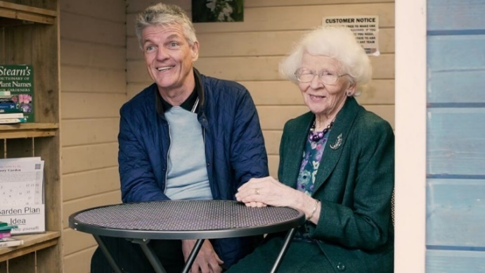
We are always on the lookout for more volunteers and a great way of giving as much information as possible to prospective volunteers is through the experiences of our current volunteers.

Would you like to share why you volunteer and what you enjoy about it? If so, we will then use it as a testimonial in our marketing and on the Sight Concern Worcestershire website. Please contact Adam Thomas, Communications and Engagement Manager, for further information. Email: a.thomas@sightconcern.co.uk

Receive this Newsletter in other Formats
We hope you enjoy reading this edition of the Volunteering Newsletter. You can also listen to an audio version on our website. If you need a copy in larger print or a screen reader version, please call us on 01905 723 245.

Sight Concern Worcestershire
The Bradbury Centre, 2 Sansome Walk, Worcester WR1 1LH. Contact us on 01905 723 245 email info@sightconcern.co.uk
Registered Charity no: 1136716 Registered Charity no: 072586

