Applicant Information Pack

Business Development Manager

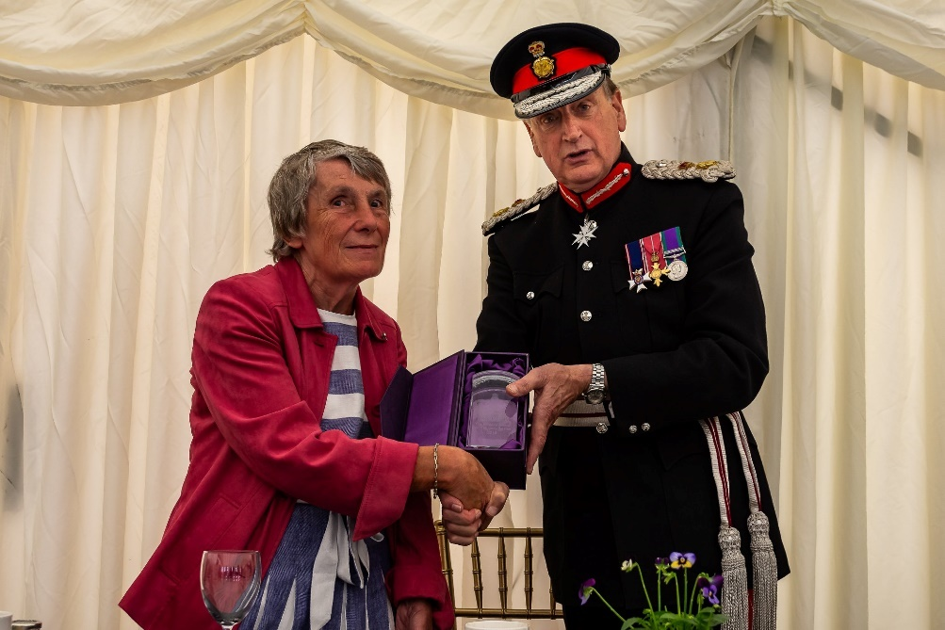

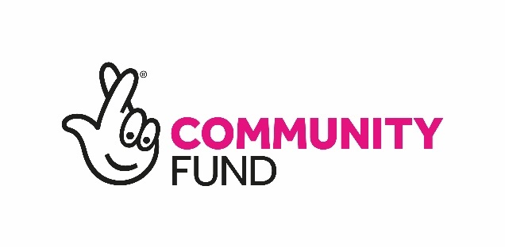

Picture of Trustee receiving crystal from the Lord Lieutenant of Worcestershire in recognition of the Queen’s Award for Voluntary Service.

Our Vision is a world where blind and partially sighted people have the confidence to reach their full potential and the opportunity to play an active role in society.

Thank you for your interest in working for Sight Concern Worcestershire.

Sight Concern Worcestershire is an independent charity that supports blind and partially sighted people to lead independent and fulfilling lives.

With roots going back to 1880, we have been successfully supporting people with sight loss for over 140 years. We’re proud of our history, and we’re excited about our future.

We believe that no one should face sight loss alone.

Especially because we know that the right support can be life changing and here’s the evidence….
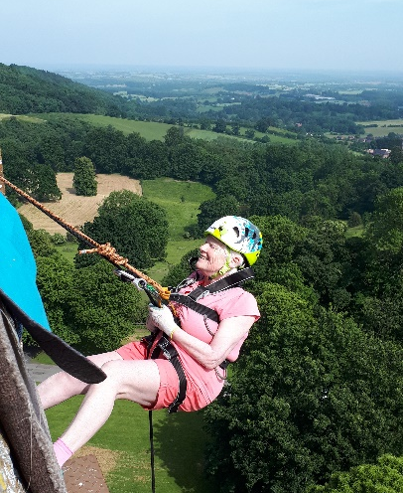
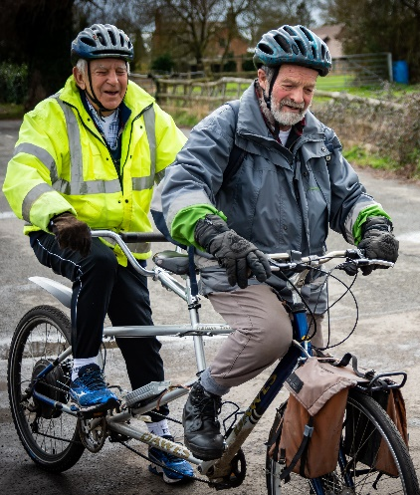

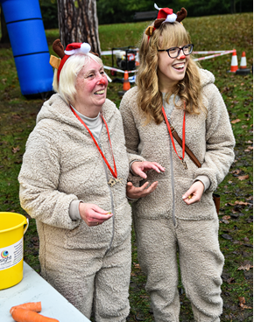
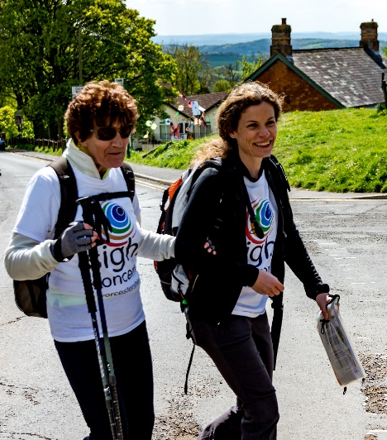
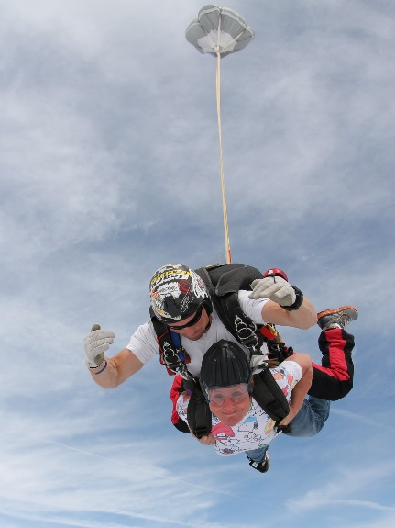

Pictures of blind and partially sighted people running, abseiling, tandem bike riding, walking the Malvern Hills, dressed up at our Reindeer Run and skydiving.

Our Mission is to support blind and partially sighted people to lead independent and fulfilling lives

Our Charitable Aims and How These are Delivered

Many people with sight loss spend years struggling unnecessarily as they are not aware of the support available to help them to adapt; it can be too overwhelming, or people don’t know where to start to look. Many people suffer from anxiety, depression, are less physically active and can become isolated as a result of not having access to this information.

We don’t want people to be struggling unnecessarily with sight loss, when we can help!

There are approximately 8,280* blind or partially sighted people living in Worcestershire. We aim to reach as many of these people as we can, within our available resources, to support them to lead the lives they wish to lead. (*RNIB Sight Loss Data Tool).

Our Strategic Priorities are to provide:
- Information, advice and guidance to enable people to make informed choices
- Expert support to enable people to adapt to sight loss and lead independent lives
- Assistance to engage in social and leisure activities to enable people to lead fulfilling lives.

Our Services include:
- Information and advice helpline
- One-to-one support from our Sight Loss Advisors
- Monthly Sight Loss Support Groups
- Living with Sight Loss courses
- Low Vision Clinics prescribing magnifiers, to make the best use of any remaining sight
- Aids and Equipment demonstrations, advice & exhibitions
- Digital Technology training through workshops and one-to-one support
- Befriending Volunteers who can support people with the things they need to do (e.g. read their post) as well as the things they love (e.g. hobbies, getting out in the community)
- Sight Loss Awareness which provides practical training on how to assist people with sight loss; for staff, volunteers, businesses and the community.

For more information about us take a look at our website www.sightconcern.co.uk
You may also want to take a look at our entry on the Charity Commission website, where you can find information including our annual reports, accounts and governing documents.

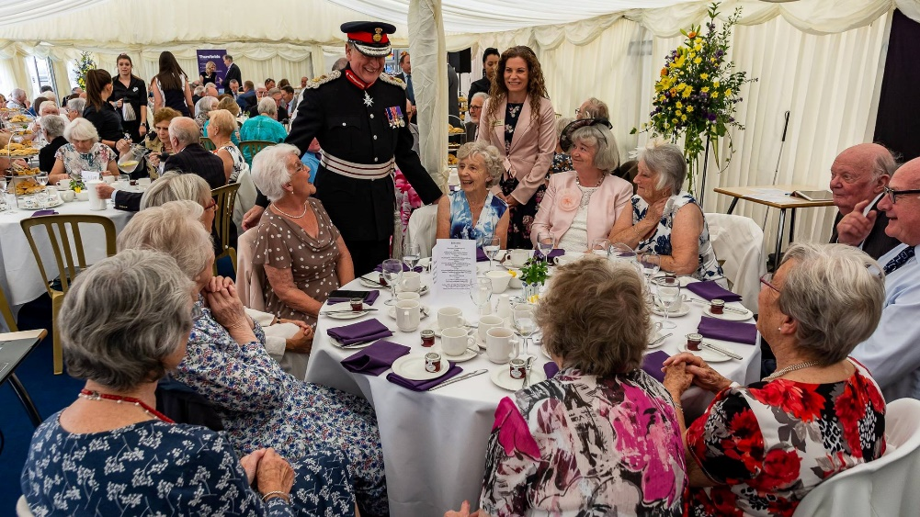

Picture of CEO and Lord Lieutenant of Worcestershire greeting smiling volunteers at an afternoon tea party to celebrate the Queen’s Award for Voluntary Service.

How do we work?

We have a small team of sixteen paid staff, most of whom work part-time. We have a network of around 160 volunteers, who carry out a variety of roles and with whom we could not survive. We are proud to have received both the Queen’s Award for Voluntary Services in 2018 and Investors in Volunteers in 2020.

We are based in Worcester city centre, at the Bradbury Centre; a large old postal sorting office that we use as our administrative base and to deliver some of our Worcester based services. We operate a flexible approach to working, where possible, with some of the team working from home.

We appreciate how challenging it can be to travel across the county, so we deliver our services across the six districts of Worcestershire, in local community settings or in people’s homes.

Background to the Role

We are recruiting for a Business Development Manager to join our Senior Management Team. This is a new role reporting into the CEO and represents an exciting opportunity to have a real impact on the work we do, and the lives of people affected by sight loss.

The impact of Covid 19 has affected the whole charitable sector and traditional fundraising in particular. We are looking to develop and further diversify our income streams, having traditionally been largely funded through Charitable Trusts and Grants and through income generated through Community Fundraising.

NHS and Social Care services are under even greater pressure both financially and in terms of capacity to deliver services. We believe there are opportunities for us to offer more cost-effective solutions to provide some of the statutory services and that this would also provide a more seamless pathway for people with sight loss. Many sight loss charities across the UK successfully deliver contracts on behalf of their local authority and NHS, by working in partnership and co-designing services we believe the right Business Development Manager could help us to obtain contracts that benefit all stakeholders.

The right aids and equipment can be life changing for people with sight loss. Some equipment is available free of charge though statutory services, but a lot of the higher end items have to be purchased. At present there aren’t any local suppliers of specialist equipment, so many people are buying off the internet. We believe we can obtain supplier agreements that will make it affordable for us to provide demonstration equipment and offer advice, so that people can browse and purchase the items that are most suitable for their needs. We need someone with commercial acumen to help us to develop this area.

Ensuring that we lever the greatest possible benefit from our Worcester city centre building requires someone with the time and energy to focus on this. The Bradbury Centre enjoys a fantastic location but is under-utilised at present. We think it has the scope to develop into a hub for the wider community, and to generate funds to support our important work across the county. How would you work towards achieving that?

We have as strong track record in obtaining funding from grants, trusts and foundations. We believe this will remain the case with the right Business Development Manager researching the best fit and making strong applications.

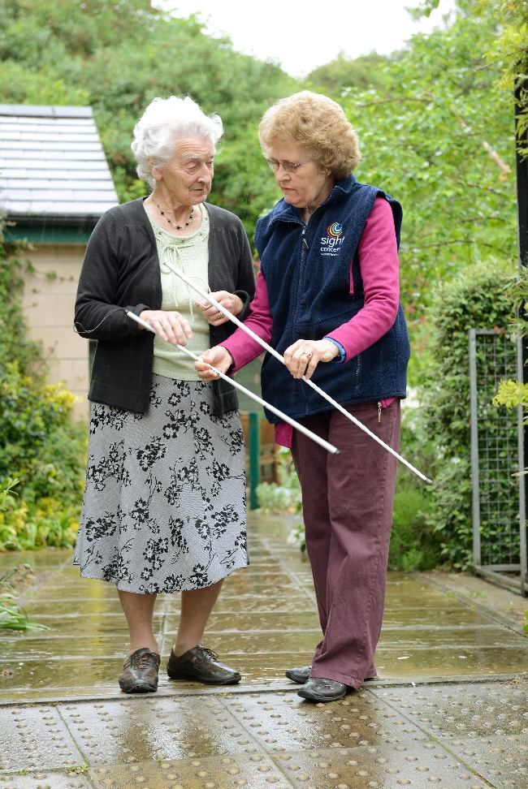
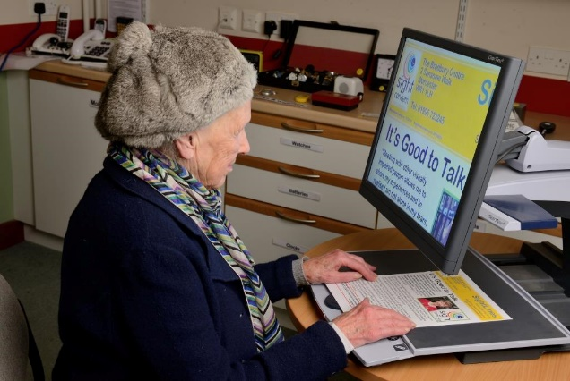

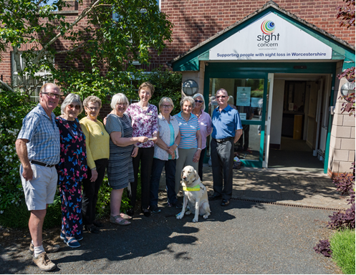

Pictures of lady using CCTV magnifier, lady being shown a white cane by a volunteer and clients and volunteers outside the Bradbury Centre.

Job Description

Business Development Manager

Hours: 22.5 hours per week - Equivalent to 3 days per week, based on a 37.5-hour week. Core hours Monday to Friday are expected but flexi time will be considered, in agreement with line manager.

Salary: £27,000- £30,000 Pro Rata / £16,200 - £18,000 Per Annum (Dependent on experience)

Location: Sight Concern’s offices or home based

Annual Leave: 20 days paid leave per year plus bank holidays, rising by one day per year, to a maximum of 25 days plus bank holidays.

Defined contribution pension scheme. The employer contribution is 3% and the employee contribution is 5%.

Job Purpose
Lead responsibility for developing and diversifying income generation for Sight Concern, including:
- Building key relationships and bidding for relevant public sector tenders/contract
- Development and oversight of commercial partnerships
- Leading on high quality bid writing and applications to grants, trusts, foundations.

Key Tasks and Responsibilities
Work with the CEO to develop and implement a new income generation strategy and identify future business development opportunities.

Lead on building relationships and preparation and submission of tenders within the public sector to help the organisation win contracts.

Lead on development of commercial partnerships for the sale of products that are of assistance to people with sight loss.

Work with the CEO to review how we can maximise the income raised from the Bradbury Centre and implement recommendations.

Work with the key colleagues to source information about client needs and our services, to inform donor proposals.

Source and write applications for grants, trusts and foundations.

Develop existing and future relationships with key donors.

Line management of key personnel and volunteers.

Person Specification

Education and Qualifications

Good level of general education, at least degree level or equivalent.

High level of spoken and written English.

In possession of a Chartered Institute of Fundraising Certificate in Fundraising, or other equivalent fundraising qualification.

Experience

Experience of driving strong income growth via different channels including at least one of the following: local authorities, NHS Trusts, CCGs, regional and national health bodies.

Demonstrable experience of building and sustaining corporate partnerships, including development and oversight of contracts and/or legally binding documents.

Demonstrable experience of project management experience, with a proven track record of success in a results-orientated environment.

Good overall ability to work in partnership with other staff, businesses and funders.

Experience of producing analysis and reports to inform and advise senior colleagues of progress, opportunities and threats.

Experience of working with budgets and financial information.

Strong diplomatic and interpersonal skills – including the ability and confidence to
network, persuade and negotiate effectively.

Demonstratable experience in working alongside people who are delivering a service to understand their needs, and to enable collection of case studies and information for reporting back to donors.

Skills

An articulate, persuasive and accurate written style, and the ability to draft compelling proposals and reports.

Ability to create and nurture new, high-value strategic partnerships.

Strong influencing and communication skills (both written and spoken), comfortable operating in a range of environments and across levels of seniority.

Self-motivated, able to meet deadlines and have strong planning and organisational skills. Ability to work under pressure on several projects at the same time, to tight deadlines, maintaining confidentiality as necessary.

Ability to prepare and implement a structured business plan with clear objectives, targets and deadlines.

Excellent computer skills, particularly MS Office.

Strong data management skills.

Qualities and Abilities

Attention to detail.

Ability to work in a team as well as independently.

How to apply?

Application forms can be downloaded from our website www.sightconcern.co.uk www.sightconcern.co.uk/about-us/job-vacancies

Applications should be marked as Private and Confidential and either emailed to k.wakefield@sightconcern.co.uk

Or posted to:
Mrs. K. Wakefield, P.A to the CEO
Sight Concern Worcestershire
The Bradbury Centre
2 Sansome Walk
Worcester
WR1 1LH

Applications close at midnight on Tuesday 16th February

Shortlisted applicants will be invited to interview by email, if you do not hear from us please assume that your application has been unsuccessful.

Interviews are expected to be held on Thursday 25th February

Interviews will be held either by video conferencing or face to face dependent on the most up to date government guidance, details will be confirmed within 48 hours of the interview.

We wish you the best of luck.

What is it like to work with Sight Concern?

Our staff are the best people to say what it’s like to work with Sight Concern, so we asked them what the most rewarding and most challenging things about working for Sight Concern were. Here’s what they told us:

“For me, the most rewarding thing is that we make a difference to people’s lives, whether it be with practical or emotional support. For example, we may be able to make suggestions about how to label food tins to make food preparation easier or support them to access a computer class so that they can stay in contact with family overseas.”

“Getting our name known and promoting the work we do can be a challenge, but this is such important work because people who need us won’t come to us unless they know we’re here”

“We support people to feel safe and as independent as they wish to be. It’s important to remember how scary - terrifying actually - that a diagnosis of sight loss can be. We help people at this moment in their lives when they’re feeling incredibly vulnerable. We support the to come to terms with it, and that’s a real privilege.”

“Often our workload can be unpredictable – people contact us with a huge range of issues, we have to be able to react and provide the support they need as soon as possible.”

“Sharing in the pleasure that people show when they have achieved things which to others might seem very small, but which to them make a world of difference!”

“Fitting all the work that needs to be done into a working day is always a challenge”

“In the wider community, we are awareness raising and informing Worcestershire people about the issues relating to sight loss and ways that people with a visual impairment can be supported.”

“Funding. It’s a challenge for us like it is for everyone in the voluntary sector, but without funding our work to support people stops.”

“Whether it’s people who use our services, or our volunteers or our staff, we help people, reach new heights and achieve things they didn’t believe possible. That’s the best thing for me.”

